

Name___________________________________. Mark= /

|  |  |  |
| --- | --- | --- |
| Test part | Possible mark | Your mark |
| Multiple choice | 20 |  |
| Short answer | 22 |  |
| Extended answer | 13 |  |
| Total | 55 |  |

HUMAN BIOLOGICAL SCIENCE. YEAR 12. 2010.

Brain and Nerve Topic Test.

***Multiple choice answer sheet.***

**Use a ball point or ink pen to mark an X** on the letter that represents the best answer from the choice of answers . Marks are not deducted for wrong answers.

|  |  |  |  |
| --- | --- | --- | --- |
| Question | Answer | Question | Answer |
| 1 | A B C D | 11 | A B C D |
| 2 | A B C D | 12 | A B C D |
| 3 | A B C D | 13 | A B C D |
| 4 | A B C D | 14 | A B C D |
| 5 | A B C D | 15 | A B C D |
| 6 | A B C D | 16 | A B C D |
| 7 | A B C D | 17 | A B C D |
| 8 | A B C D | 18 | A B C D |
| 9 | A B C D | 19 | A B C D |
| 10 | A B C D | 20 | A B C D |

1. The cerebellum is concerned with _______________.
2. conditioning
3. memory
4. coordination and precision
5. intelligence
6. At the synapses, the impulses are always passed from the…..
7. axon to the dendrites
8. dendrites to the axon
9. either way is possible
10. cyton to the dendrites
11. The medulla oblongata is best described as:
12. A structure in the cerebrum that contains the cardiac, respiratory, vomiting and vasomotor centers and deals with autonomic functions, such as breathing, heart rate and blood pressure.
13. A structure in the brain stem that contains the cardiac, respiratory, vomiting and vasomotor centers and deals with autonomic functions, such as breathing, heart rate and blood pressure.
14. A structure in the brain stem that controls water balance and hormone production.
15. A structure in the cerebellum that contains neurons concerned with memory.
16. In myelinated neurons:
17. The action and resting potential is seen all along the axon.
18. The action potential only is seen along the axon.
19. The action and resting potential is only seen at the nodes of Ranvier.
20. There is never a resting potential.
21. Which of the following statements is correct?
22. In the spinal cord and brain the grey matter is to the outside.
23. In the spinal cord the grey matter is to the outside. In the brain the white matter is to the outside.
24. In the spinal cord the white matter is to the outside. In the brain the grey matter is to the inside.
25. There is no grey matter in the spine.
26. Which of the following statements about Schwann cells is correct?
27. Schwann cells help form the myelin sheath.
28. Schwann cells are not found in the white matter.
29. Schwann cells are only found in the grey matter.
30. Schwann cells are only found on sensory neurons.
31. The most obvious difference between the human brain and the brain of a fish would be in the:

A. hypothalamus.

b. thalamus.

c. cerebellum.

d. cerebral cortex.

1. An elderly acquaintance of yours has suffered from partial blindness since she had a stroke. Apparently the stroke damaged her

a. occipital lobe.

b. parietal lobe.

c. temporal lobes.

d. reticular formation

1. The cerebral cortex is composed of two sides or __________.

a. Pons

b. positrons

c. connector neurons

d. hemispheres

1. Which of the following changes would you expect to occur in someone whose frontal lobes were damaged in an accident?

a. development of blank spots in the visual field

b. reduced capacity to hear high frequency sounds

c. reduced reasoning and planning abilities and changes in personality

d. inability to demonstrate complex motor skills

1. At the point where a neuron stimulates a muscles neurotransmitters receptors are located in the:
2. Dendrites
3. Synaptic cleft
4. Sarcolemma
5. Actin and myosin
6. The degree of muscles contraction in a skeletal muscle is influenced by:
7. The number of motor endplates.
8. The number of ATP receptors
9. The absence of Transmitter receptors.
10. The surface area of the synaptic cleft.
11. Which of the following is not found in the CSF?
12. Urea
13. White blood cells
14. Glucose
15. Acetycholine
16. If a nerve impulse of 15 millivolts or more stimulates a neuron:
17. The All-or-none response begins.
18. Sodium ions will move out of the axon through the membrane.
19. Acetylcholinerase will be reabsorbed.
20. The motor end plate will relax.
21. Saltatary conduction is seen in:
22. All neurons
23. Only motor neurons
24. Myelinated neurons
25. Non myelinated neurons

Use the following graph to answer questions 16 and 17.

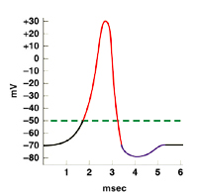

1. During which time period are sodium gates open?
2. 1 to 2 msec.
3. 2 to 3 msec.
4. 3 to 4 msec.
5. 4 to 5 msec.
6. What is the resting potential for this neuron?
7. -70mV
8. -50mV
9. +30mV
10. 15mV
11. Which of the following gives the correct pathway for a nerve impulse that is bringing about skeletal muscle contractions?
12. Cerebrum, Pons and muscle.
13. Cerebrum, cerebellum and muscle.
14. Cerebellum, cerebrum and muscle.
15. Pons, cerebrum and muscle.
16. When coordinating muscle movement:
17. Sensory neurons collect information from propriorecptors in the joints and sensory neurons in the middle ear.
18. Motor neurons collect information from propriorecptors in the joints and sensory neurons in the middle ear.
19. Sensory neurons in the eyes and ears only bring information on body position to the Pons.
20. Sensory neurons in the eyes and ears only, bring information on body position to the Cerebrum.
21. A reflex arc response contributes to homeostasis by:
22. Keeping body temperature constant.
23. Keeping the ion balance constant in the body fluids.
24. Keeping the middle ear sensory neurons constant.
25. Preventing serious injury.

Short answer questions

1. Complete the table below for the meninges.

|  |  |
| --- | --- |
| layer | Description |
| Outer |  |
| Middle |  |
| Inner |  |

(3 marks)

1. Label the diagram below and use it to answer the questions that follow.

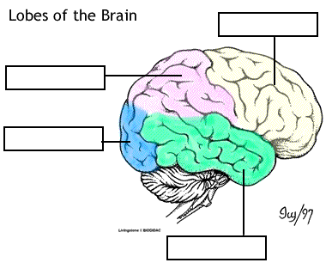

(2 marks)

II. The largest structure shown above is the ________ of the human brain. The convolutions on the surface of this structure are known as the _______ and the _________. These convolutions increase the __________ _____ of this part of the brain. The outer layer of this structure is known as the __________ matter or _________ ___________. It has this colour many of the neurons that make it up are __________________.

(3.5 marks)

III. Based on the previous diagram complete the table below.

|  |  |
| --- | --- |
| Functional area | Lobe of brain that the area is located in |
| Sensory |  |
| Movement |  |
| Personality |  |
| Vision |  |
| Smell |  |

(2.5 marks)

3. Use this diagram to answer the question that follows.

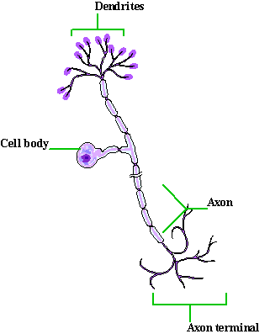

What type of cell is shown in the diagram above? Give a reason for your answer.

__________________________________________________________________________________________________________________________________________________________________________________________

1. marks)

4. Use the diagram that follows to complete the table below.

Nerve transmission at a Synapse

A

B

C

D

|  |  |
| --- | --- |
| Event | State what is happening at each event |
| A |  |
| B |  |
| C |  |
| D |  |

1. marks)

5. use the diagram below of a foot standing on a nail, to help you name the structures that make up a reflex arc.

(5 marks)

|  |  |  |  |
| --- | --- | --- | --- |
| Structure | Name | Structure | Name |
| A |  | D |  |
| B |  | E |  |
| C |  |  |  |

EXTENDED ANSWER QUESTION

1. Describe how a nerve impulse is transmitted along an axon. Use diagrams where appropriate.

(13 marks)

_____________________________________________________________________________________________________________________________________________________________________________________________________________________________________________________________________________________________________________________________________________________________________________________________________________________________________________________________________________________________________________________________________________________________________________________________________________________________________________________________

_____________________________________________________________________________________________________________________________________________________________________________________________________________________________________________________________________________________________________________________________________________________________________________________________________________________________________________________________________________________________________________________________________________________________________________________________________________________________________________________________

_____________________________________________________________________________________________________________________________________________________________________________________________________________________________________________________________________________________________________________________________________________________________________________________________________________________________________________________________________________________________________________________________________________________________________________________________________________________________________________________________

_____________________________________________________________________________________________________________________________________________________________________________________________________________________________________________________________________________________________________________________________________________________________________________________________________________________________________________________________________________________________________________________________________________________________________________________________________________________________________________________________